Site Visit was conducted by Hang Monycheat
Dated on 02-Mar-2018

Map: Collateral (The purchased house)
Address: No. 97EoE1E2, St. The Flora 1 (6A4), S/K Bak Khaeng, Khan Chroy Changva, Phnom Penh.

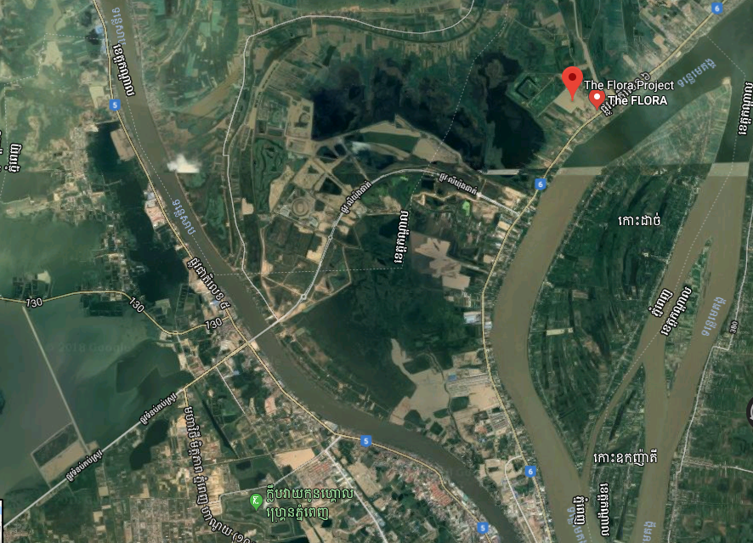
Subject Property
(The purchased house)

Along National Road No. 6A

Oknha LY YONG PHAT’s Road

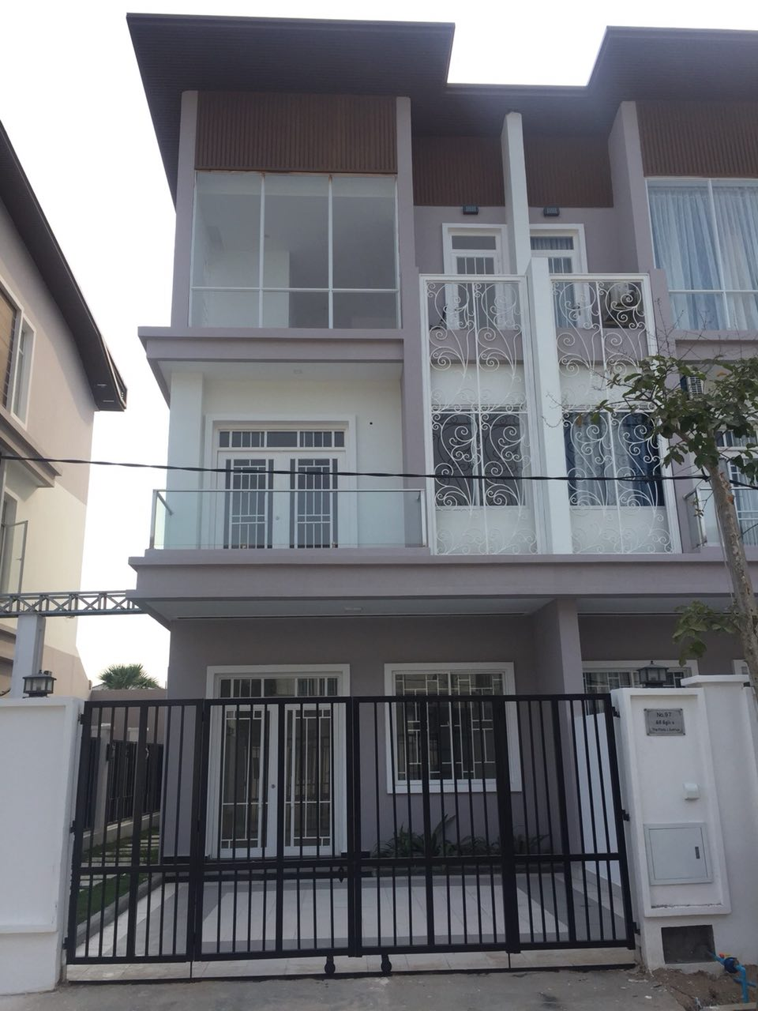
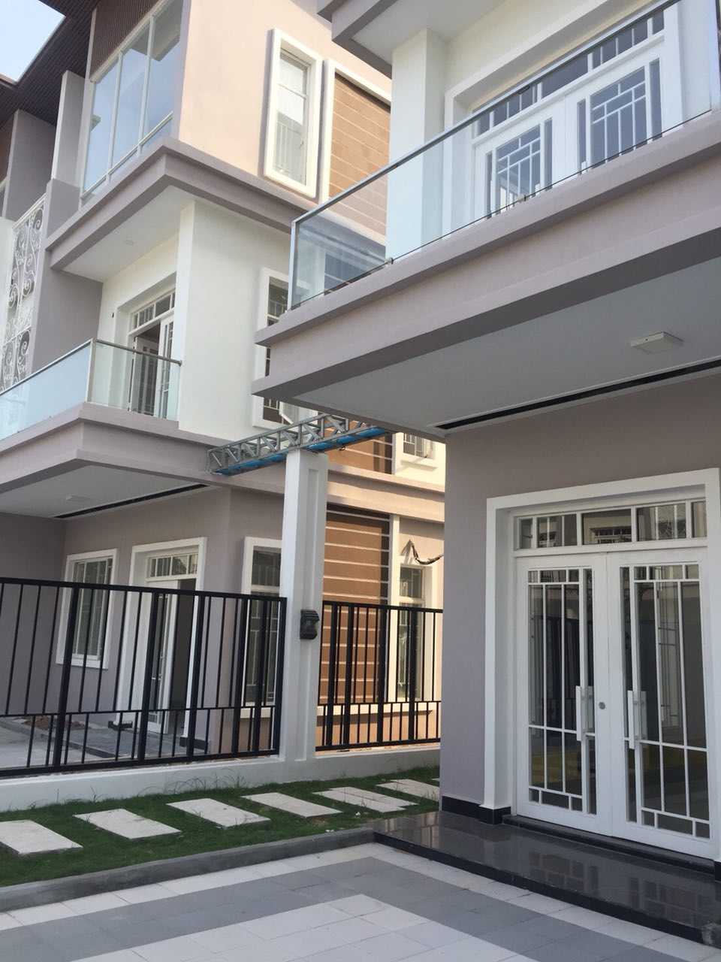

Subject Property

